Department: Earth and Environment
Topic title: “Magmatic processes and time scales at monogenetic and polygenetic volcanoes of Mexico”
Name and email of the candidate: Daniel Alberto Gómez Calderón (dagcbeto@gmail.com)
Supervisor: Fidel Costa (costa@ipgp.fr)
Institut de Physique du Globe de Paris, Université Paris Cité
Co-Supervisor: Claus Siebe (csiebe@geofisica.unam.mx)
Universidad Nacional Autónoma de México.
Host Laboratory and team: Volcanic Systems at IPGP.
Possible funding or half-funding: Mexican scholarship program “Becas al extranjero para estudios de posgrado 2023” given by Consejo Nacional de Ciencia y Tecnología (CONACYT).

Details on the topic and organization:
1. Background.
Volcanism has accompanied society since the beginning, nevertheless, our ability to forecast volcanic eruptions and evaluate their hazards is still limited. In the recent decades there has been a major improvement of the knowledge about the magmatic plumbing systems and the time of magma transfer from the source to the surface. These data are fundamental for improved volcano monitoring and forecasting. Progress has been achieved through geochemical and petrological studies using whole rock composition, major and trace elements and isotopic compositions of minerals (Costa et al., 2020; Chakraborty, 2022). Crystals from mafic volcanoes record timescales of days to years between magma intrusion and eruption, which broadly match those recorded by monitoring data. Whereas the timescales recorded in felsic crystals spanning decades to millennia (Figure 1) (Costa et al., 2021).
The diffusion chronometry studies have been carried out worldwide in various tectonic environments as New Zealand (Brenna et al.,2018), Antarctica (Li et al., 2023), India (Ray et al., 2016), Italy (Iovine et al., 2017; Ubide et al., 2019), Alaska (Reagan et al., 2017), among other. In Latin America, few works in plumbing systems have been done, e.g. México (Johnson et al., 2008; Albert et al., 2020; Larrea et al., 2021), Chile (Ruth et al., 2018), Costa Rica (Oeser et al., 2018) and Colombia (Murcia et al., 2019). The timescales also have been studied in meteorites (Chakraborty and Dohmen, 2022). The diffusion chronometry combined with other monitoring techniques such as geophysical, geodetic and geochemical can estimate a very accurate volcanic hazard 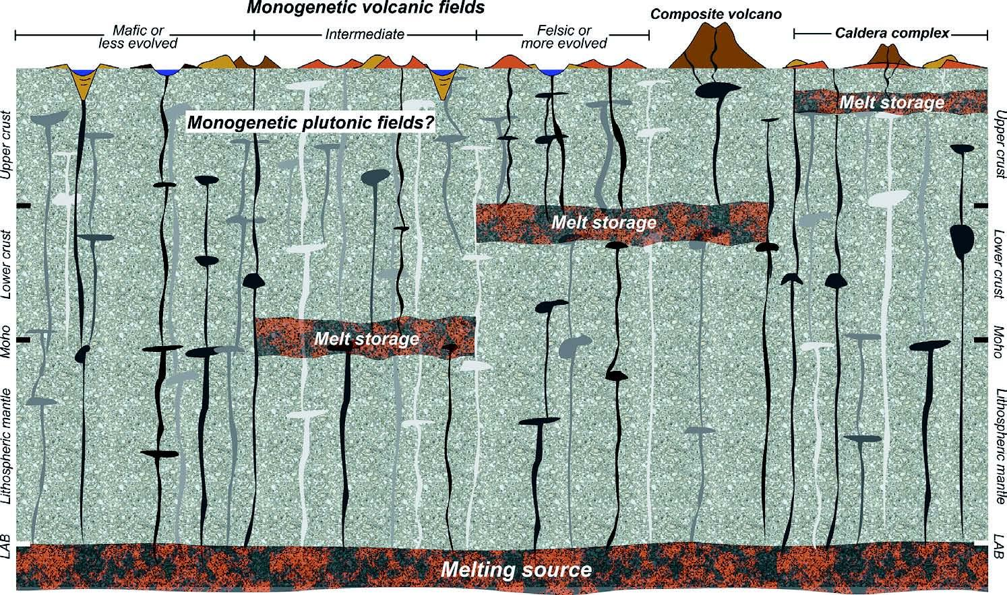estimation (Costa et al., 2020).
Figure 1. Schematic framework of magmatic plumbing systems for monogenetic volcanic fields. LAB:
Lithosphere-Asthenosphere Boundary. Not to scale. Taken from Murcia et al., 2019.

In this PhD we propose to study the plumbing system, time scales of magma transfer and geological relations of monogenetic volcanoes and their relationship to larger polygenetic volcanoes. Monogenetic volcanism is the most abundant type of subaerial volcanism on Earth and commonly are grouped in clusters or volcanic fields. Those are characterized by small volume vents of mafic magma (~1 km³) emitted during a few days to several years (Nemeth, 2010; Cañón-Tapia, 2016). Commonly, monogenetic centers are perceived as low risk due to their relatively small size and low frequency of eruptions compared with polygenetic volcanoes.
Due to the fact that monogenetic volcanism does not reflect patterns in time and space, and geophysical warning systems typically lack sufficient empirical record with which to compare real time signals, it is crucial to decipher source to surface magmatic pathways (Smith and Németh, 2017; Larrea et al., 2021). Therefore, understanding the plumbing system in volcanic regions becomes a critical factor to effectively assess the volcanic hazard.

2. Study zone.
One of the most interesting and varied volcanic arc in the world is the Transmexican Volcanic Belt (Gómez-Tuena et al., 2005, 2018; Ferrari et al., 2012), which include monogenetic volcanism (Figure 1; e.g. Michoacán-Guanajuato, Chichinautzin, Los Tuxtlas field) and highest concentration of stratovolcanoes in the country (e.g. Colima, Popocatépetl, Pico de Orizaba, Chichón). The largest volcanic field of México is the Michoacán-Guanajuato states (MGVF, Hasenaka & Carmichael, 1985a; Valentine & Connor, 2015). This field include more than 2000 volcanic vents of different types, such as: scoria and spatter cones, maars, tuff ring, domes, tuff cones, small shield volcanoes, stratovolcanoes and calderas, each one with particular volcanic hazards associated (Figure 2 and 3) (Hasenaka & Carmichael, 1985a; Connor, 1987; Gómez-Calderón et al., 2023).
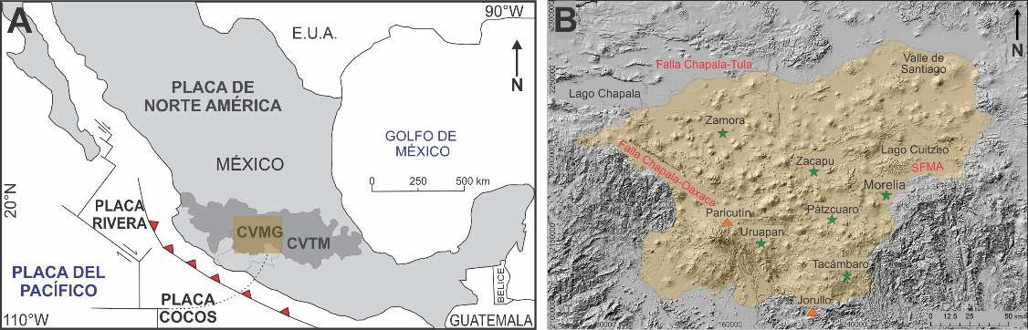

Figure 2. A. Tectonic setting of the Transmexican volcanic Belt (CVTM) and location of the Michoacán-Guanajuato volcanic field (CVMG) (A and B). Taken from Gómez-Vasconcelos, 2018.

Although small volume volcanism is distributed in large areas, its product volumes are similar or higher than polygenetic volcanism. For example, the MGVF is an active volcanic zone and has over 700 km³ of volcanic products emplaced in the last 3 Ma (Hasenaka & Carmichael, 1985a). This volume equates to 72 times the Colima volcano (Gómez-Calderón, 2018). Besides Parícutin volcano “born” 80 years ago, the last 20 years the Parícutin region has presented seismic swarms which remind us of the activity of the volcanic system (Legrand et al., 2023). Nowadays, a similar eruption to the Jorullo or Parícutin volcanoes could generate enormous social, economic and environmental impacts, considering that the population has increased exponentially.

3. Problem statement and research question
Even though high volcanic density and abundant Holocene volcanism are present in México (over 30 vents; Macias & Arce, 2019), the knowledge about the plumbing system dynamics and associated hazards of monogenetic volcanism is scarce in comparison with polygenetic volcanoes such as Popocatepetl or Colima (Larrea et al., 2021). For this reason, the MGVF is an excellent study area for understanding magmatic plumbing systems (Hasenaka y Carmichael, 1985a; Connor, 1987; Mazzarinni et al., 2010; Pérez-López et al., 2011; Guilbaud et al., 2011; Di Traglia et al., 2014; Cañón-Tapía, 2016; Larrea et al., 2021; Torres-Sánchez et al., 2022). This research proposes a chronometry diffusion analysis of different zoned mineral of diverse volcanoes typology and magmatic series (mafic, shoshonitic, alkaline) within the MGVF. This with the intention to contribute to the understanding of the complexity of the magmatic plumbing systems in volcanic fields and to the volcanic hazard assessment. Additionally, the chronometry diffusion models can help to improve land planning, response and mitigation plans. The principal questions that guide this research are: ¿What is the magma dynamics from source to surface of different volcano typology? ¿Are there a relationship between magma batches features and volcano typology and/or volcanic arc zones? ¿Are there diffusivity signatures associated with specific volcano typology or/and magmatic series? ¿How long would it take for the magma to ascend to the surface after the first geophysical signals in the future? ¿Which regions have high probability of emplacement of a new volcanic system?

4. Methods.
The general method of doctoral research includes field campaigns, analytical sessions and research work.
4.1. Field campaigns.
The first phase will consist of sampling the pyroclastic products of different volcano typology (spatter, cinder cone, maar, shield volcano, stratovolcano). In case pyroclasts are absent, lavas will be sampled.
4.2. Analytical methods.
The petrology and geochemical characterization will be done with a polarizing optical microscope, scanning electron microscope (SEM) and electron probe micro-analyzer (EPMA). Major element crystal compositions will be analyzed by EPMA though core-to-rim traverses on olivine, pyroxene, feldspar, quartz, spinel and apatite with a spacing of 2-4 um at (IPGP/USorbonne). Electron backscattered diffraction (EBSD) obtained from the SEM will be used to determine the orientation of the crystallographic axes. Multi-element compositional maps will be obtained via laser ablation inductively coupled plasma mass spectrometry (LA-ICP-MS).
4.3. Diffusion chronometry
The diffusion chronometry is based on mineral zonation and gradients in the composition of crystals. The formation of chemical gradients in crystals and/or melts drives the diffusion of molecules or elements during magma storage at high temperatures as the system attempts to return to equilibrium. Through the diffusivities of different elements, we can calculate the timescale of diffusive re-equilibration using the Fick’s second law of diffusion or more sophisticated models (Costa et al., 2008; Costa, 2021). The wide range of elemental diffusivities means that multiple elements can be exploited simultaneously to obtain a more accurate picture of the variety of processes and timescales that can be recorded in a single mineral (Costa et al., 2020).
5. Expected research outcomes.
In general, the goals of the research are: i) generate a geochemical-petrological data base from different volcano typology, ii) generate diffusion chronometry and thermobarometry models, and iii) contribute to the assessment of volcanic hazards. Those will be exposed in three research articles.
- Unraveling the magmatic plumbing system of Michoacán Guanajuato volcanic field, México: diffusion chronometry and thermobarometry of subalkaline, shoshonitic and alkaline lavas.
- Mafic cumulates in small-scale volcanism, a window for complexity of magmatic plumbing systems.
- Volcanic hazards of central Transmexican Belt: a diffusion chronometry approach.

6. PhD Timeline
Activity | Year
 | 1 |  |  |  | 2 |  |  |  |  | 3
 | Trimester
 | 1 | 2 | 3 | 4 | 5 | 6 | 7 | 8 | 9 |  | 10 | 11 | 12
Literature review
Write “State of the Art” chapter
Field work
Sample preparation
Acquisition of mineral chemical data
Writing of 1st article
Writing of 2nd article
Writing of 3rd article
Conclusion

7. References
Albert, H., Larrea, P., Costa, F., Widom, E., Siebe, C. 2020. Crystals reveal magma convection and melt transport in dyke-fed eruptions. Sci. Rep. 10(1):11632.
Brenna, M., Cronin, S.J., Smith, I.E.M, Tollan, P.M.E.., Scott, J.M. 2018. Olivine xenocryst diffusion reveals rapid monogenetic basaltic magma ascent following complex storage at Pupuke Maar, Auckland Volcanic Field, New Zealand. Earth Planet. Sci. Lett. 499:13–22
Cañón-Tapia, E., 2016. Reappraisal of the significance of volcanic fields. Journal of Volcanology and Geothermal Research, 310, 26-38.
Chakraborty, S., & Dohmen, R. 2022. Diffusion chronometry of volcanic rocks: looking backward and forward. Bulletin of Volcanology, 84(6), 57.
Connor, C. B.,1987. Structure of the Michoacán-Guanajuato volcanic field, Mexico. Journal of Volcanology and Geothermal Research, 33(1-3), 191-200.
Costa F, Dohmen R, Chakraborty S. 2008. Time scales of magmatic processes from modeling the zoning patterns of crystals. Rev. Mineral. Geochem. 69(1):545–94.
Costa, F., Shea T., Ubide T. 2020. Diffusion chronometry and the timescales of magmatic processes. Nat. Rev. Earth Environ. 1(4):201–14.
Costa, F. 2021. Clocks in magmatic rocks. Annu Rev Earth Planet Sci 49:231–252.
Di Traglia, F., Morelli, S., Casagli, N., & Monroy, V. H. G. 2014. Semi-automatic delimitation of volcanic edifice boundaries: Validation and application to the cinder cones of the Tancitaro–Nueva Italia region (Michoacán–Guanajuato Volcanic Field, Mexico). Geomorphology, 219, 152-160.
Ferrari, L., Orozco-Esquivel, T., Manea, V., & Manea, M. 2012. The dynamic history of the Trans-Mexican Volcanic Belt and the Mexico subduction zone. Tectonophysics, 522, 122-149.
Gómez-Calderón, D.A., Corona-Chávez, P., Soria-Caballero, D.C. 2023. Vulcanotectonic domains of the Michoacán Guanajuato Volcanic Field, México. Congreso Internacional Parícutin 80, México.
Gómez-Calderón, D.A. 2018. Relación morfométrica y estructural del vulcanismo mono/poligenético en la porción sureste del Campo Volcánico Michoacán Guanajuato. Universidad Nacional Autónoma de México, Morelia, Michoacán, México, tesis licenciatura, 167 pp.
Gómez-Tuena, A., Orozco-Esquivel, M., & Ferrari, L. 2005. Petrogénesis ígnea de la faja volcánica transmexicana. Boletín de la Sociedad Geológica Mexicana, 57(3), 227-283.
Gómez-Tuena, A., Mori, L., & Straub, S. M. 2018. Geochemical and petrological insights into the tectonic origin of the Transmexican Volcanic Belt. Earth-Science Reviews, 183, 153- 181.
Gómez-Vasconcelos, M. G. (2018). El volcán Paricutín en el campo volcánico Michoacán-Guanajuato: una revisión. Ciencia Nicolaita, 74, 15-30.
Guilbaud, M. N., Siebe, C., Layer, P., Salinas, S., Castro-Govea, R., Garduño-Monroy, V. H., Le Corvec, N., 2011. Geology, geochronology, and tectonic setting of the Jorullo Volcano region, Michoacán, México. Journal of Volcanology and Geothermal Research, 201(1-4), 97-112.
Hasenaka, T., Carmichael, I.S.E., 1985a. The cinder cones of Michoacán—Guanajuato, central Mexico: their age, volume and distribution, and magma discharge rate. Journal of Volcanology and Geothermal Research, 25(1-2), 105-124.
Iovine, R. S., Fedele, L., Mazzeo, F. C., Arienzo, I., Cavallo, A., Wörner, G., ... & D’Antonio, M. 2017. Timescales of magmatic processes prior to the∼ 4.7 ka Agnano-Monte Spina eruption (Campi Flegrei caldera, Southern Italy) based on diffusion chronometry from sanidine phenocrysts. Bulletin of Volcanology, 79, 1-15.
Johnson, E. R., Wallace, P. J., Cashman, K. V., Granados, H. D., Kent, A. J., 2008. Magmatic volatile contents and degassing-induced crystallization at Volcán Jorullo, Mexico: Implications for melt evolution and the plumbing systems of monogenetic volcanoes. Earth and Planetary Science Letters, 269 (3-4), 478-487.
Larrea, P., Albert, H., Ubide, T., Costa, F., Colás, V., Widom, E., Siebe, C. 2021. From explosive vent opening to effusive outpouring: mineral constraints on magma dynamics and timescales at paricutin monogenetic volcano. Journal of Petrology, 62(4), egaa112.
Li, W., Costa, F., Oppenheimer, C., & Nagashima, K. 2023. Volatile and trace element partitioning between apatite and alkaline melts. Contributions to Mineralogy and Petrology, 178(2), 9.
Macías, J. L., & Arce, J. L. 2019. Volcanic Activity in Mexico During the Holocene. In The Holocene and Anthropocene Environmental History of Mexico (pp. 129-170). Springer.
Mazzarini, F., Ferrari, L., & Isola, I. 2010. Self-similar clustering of cinder cones and crust thickness in the Michoacan–Guanajuato and Sierra de Chichinautzin volcanic fields, Trans-Mexican Volcanic Belt. Tectonophysics, 486(1-4), 55-64.
Murcia, H., Borrero, C., & Németh, K. 2019. Overview and plumbing system implications of monogenetic volcanism in the northernmost Andes' volcanic province. Journal of Volcanology and Geothermal Research, 383, 77-87.
Németh, K. 2010. Monogenetic volcanic ﬁelds: Origin, sedimentary record, and relationship with polygenetic volcanism. In What Is a Volcano? GSA Special Paper (Vol. 470, p. 43).
Oeser, M., Ruprecht, P. & Weyer, S.2018. Combined Fe- Mg chemical and isotopic zoning in olivine constraining magma mixing- to- eruption timescales for the continental arc volcano Irazú (Costa Rica) and Cr diffusion in olivine. Am. Mineral. 103, 582–599.
Pérez-López, R., Legrand, D., Garduño-Monroy, V. H., Rodríguez-Pascua, M. A., & Giner- Robles, J. L. 2011. Scaling laws of the size-distribution of monogenetic volcanoes within the Michoacán-Guanajuato Volcanic Field (Mexico). Journal of Volcanology and Geothermal Research, 201(1-4), 65-72.
Ray, A., Hatui, K., Paul, D. K., Sen, G., Biswas, S. K., & Das, B. 2016. Mantle xenolith-xenocryst-bearing monogenetic alkali basaltic lava field from Kutch Basin, Gujarat, Western India: estimation of magma ascent rate. Journal of Volcanology and Geothermal Research, 312, 40-52.
Reagan, M. K., Sims, K. W. W., Erich, J., Thomas, R. B., Cheng, H., Edwards, R. L., Ball, L. 2003. Time-scales of differentiation from mafic parents to rhyolite in North American continental arcs. Journal of Petrology, 44(9), 1703-1726.
Smith, I. E. M., & Németh, K. 2017. Source to surface model of monogenetic volcanism: a critical review. Geological Society, London, Special Publications, 446(1), 1-28.
Torres-Sánchez, D., Sosa-Ceballos, G., Bolós, X., & Macías, J. L., 2022. Petrogenesis of mafic-intermediate magmatism of the Michoacán–Guanajuato volcanic field in Western Mexico. A geochemical review. Frontiers in Earth Science, 10.
Ubide, T., Caulfield, J., Brandt, C., Bussweiler, Y., Mollo, S., Di Stefano, F., Nnazzari, M., Scarlato, P. 2019. Deep magma storage revealed by multi-method elemental mapping of clinopyroxene megacrysts at Stromboli volcano. Frontiers in Earth Science, 7, 239.
Valentine, G. A., Connor, C. B., 2015. Basaltic volcanic fields, in: Academic Press (Second Edition), The encyclopedia of volcanoes, pp. 423-439.

